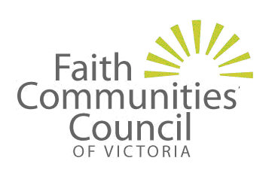
A Place For All – Faith and Community
for People with Disabilities

What is your experience of participating in a faith community?
Or trying to access a faith community?
How can leadership make a difference?
Do you have any ideas about how to make things better?
---------------------------------------------------
When: Tuesday May 17, 2011, 9:30am – 4:00pm
Where: Uniting Church Centre, 130 Little Collins Street, Melbourne
(Please see the map over the page)

Presentations (include):

• ‘Keeping Faith’ Project–a collaboration with Inclusion Melbourne, local multi-faith networks and the City of Port Phillip
• ‘To Belong I need to be Missed’ Multifaith Disability and Inclusion in Buddhist, Christian, Jewish and Muslim communities
• “Exploring Spirituality” - Pinarc Support Services, Ballarat
• There will also be an opportunity to discuss issues and make ongoing connections.

Then at 4:15pm, launch of Buddhist Council of Victoria’s booklet: ‘Provision of Disability Access to Places of Worship for the Buddhist Community’ by Dr. Ian Gawler, retired founder of the Gawler Foundation and author.

---------------------------------------------------

A light lunch will be provided. Attendant support workers and Auslan interpreters will be present.

Gold coin entry up to $5.

RSVP by Friday May 6 at the latest to ensure your place.
P: (03) 9251 5255 or E: david.wang@victas.uca.org.au
Please indicate whether you have any dietary or access requirements.

Unable to attend the forum?

Please go to http://blogs.victas.uca.org.au/disabilityinclusion/ and tell us about your experiences.

Hosted by the Uniting Church, this forum is supported by the Victorian Multicultural Commission, the Victorian Council of Churches and the Faith Communities Council of Victoria.

Map of Uniting Church Centre at 130 Little Collins Street Melbourne:
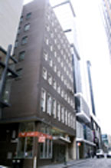
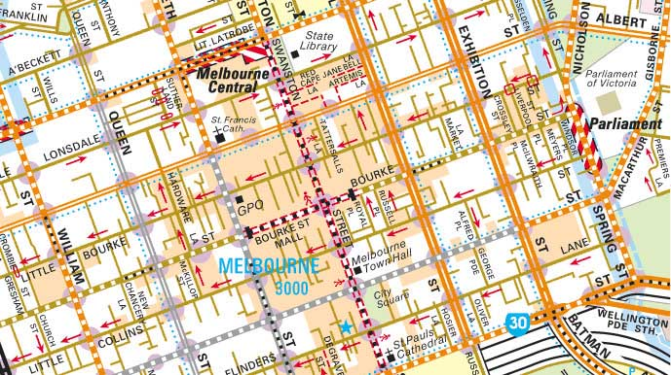

Copyright 2010 Melway Publishing Pty Ltd. Reproduced from Melway Edition 38 with permission.

How to get to the Uniting Church Centre:

• By Tram - It’s best to stop at Bourke Street tram stop at Russell street corner, then walk up the Russell Street hill. Next, turn left into Little Collins Street & Uniting Church Centre is on your left side.
• Or Collins Street tram - The stop is between Exhibition Street and Russell Street. Just walk down Alfred Place, turn left into Little Collins Street & Uniting Church Centre is on your right side.
• By Train - The best train stop is Flinders Street Station. Then walk along Swanston Street & turn right when you reach Little Collins Street. After you have passed Russell St, Uniting Church Centre is on your left side.

