

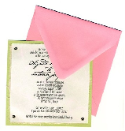
Invitation
From Multi-faith Disability Inclusion Project
Come to our talk and lunch.


We want to find out what helps or stops people with a disability joining faith communities.
For example, joining in worship, teachings, social activities and festivals.
We want you to share your ideas.


Special Guests
A range of interesting speakers about faith and disability.

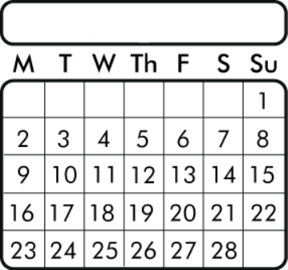
May
2011
When
Tuesday, May 17, 2011
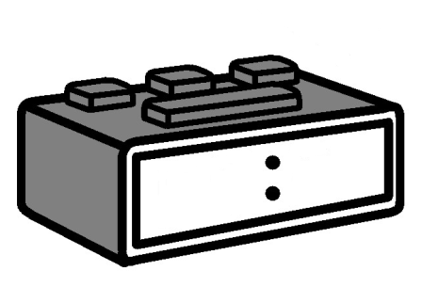
9
3
0

Time

9.30 start and finish 4.00. At 4.15 the Buddhist Council of Victoria will launch its new Disability Access book. Special Guest will be Dr Ian Gawler.

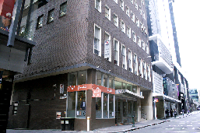
Where

Uniting Church Centre

130 Little Collins Street

Melbourne.



You need to pay gold coins up to $5


Thank you to
- Uniting Church
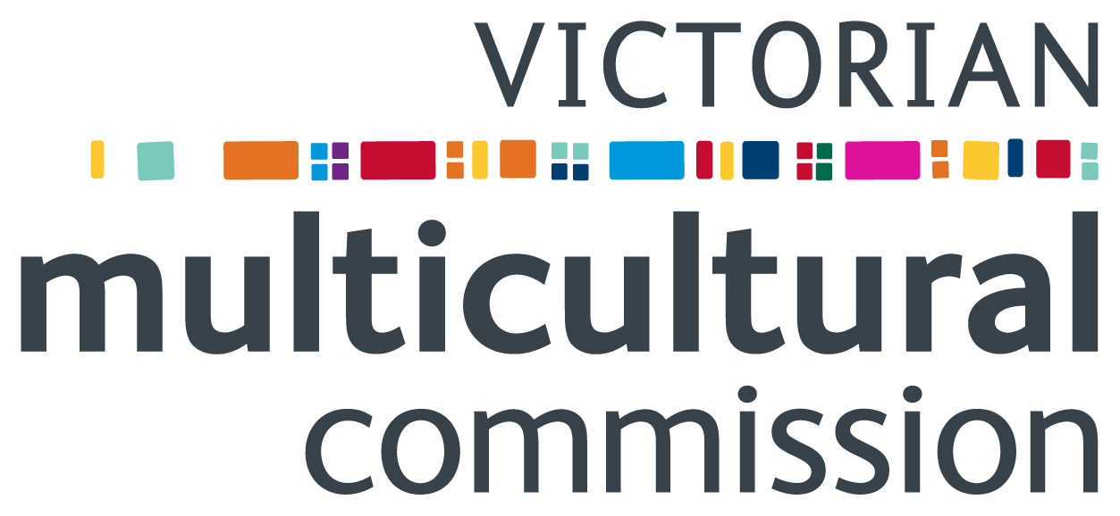
- Victorian Multicultural Commission
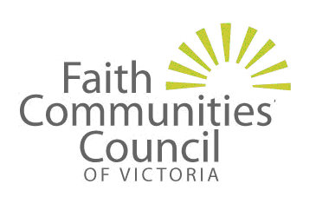

- Faith Communities Council of Victoria
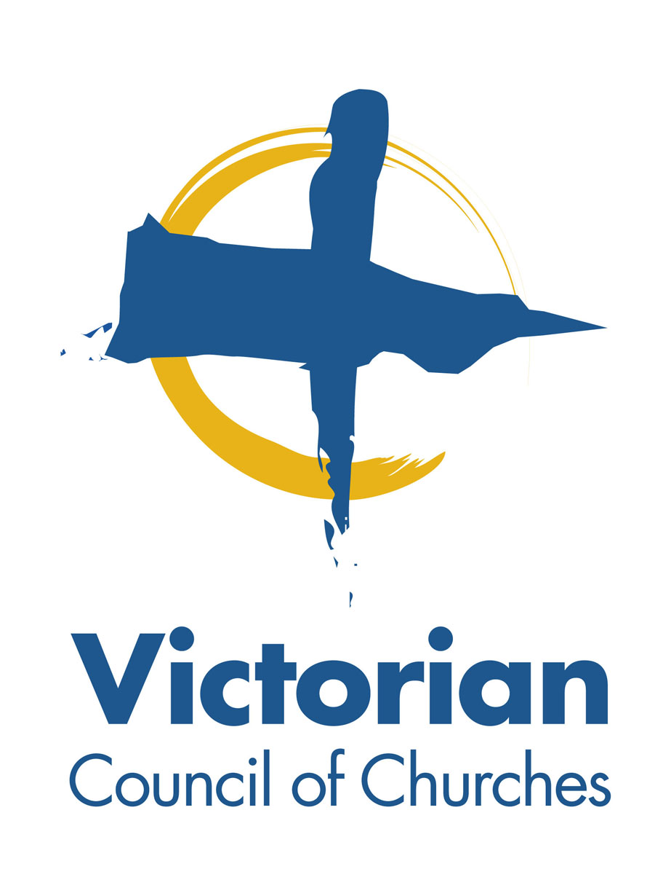
- Victorian Council of Churches


To reply

Call David Wang

Phone number 9251 5255, or email
david.wang@victas.uca.org.au

May
2011

Phone before Friday, May 6, 2011


There will be food and drink. Tell us about your dietary needs.


There will be
- Carer support


and

- Auslan interpreter.

To get to the Uniting Church Centre.
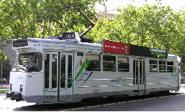
The best tram stop is
- Bourke Street tram at Russell street corner.

Then

- Walk up the Russell Street hill
- Turn left into Little Collins Street
- Uniting Church Centre is on your left side.

Or

- Collins Street tram. The best stop is a superstop. The stop is between Exhibition Street and Russell Street.
Then
- Walk down Alfred Place
- Turn left into Little Collins Street
- Uniting Church Centre is on your right side.

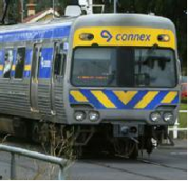
The best train stop is
Flinders Street Station.
Then
- Walk along Swanston Street to Little Collins Street
- Turn right into Little Collins Street
- Go across Russell Street
- Uniting Church Centre is on your left side.
Easy English written for the Uniting Church by the Communication Resource Centre, Scope. March 2011. www.scopevic.org.au
The Picture Communication Symbols © 1981 – 2010 by Mayer-Johnson LLC. All Rights Reserved Worldwide. Used with Permission.

